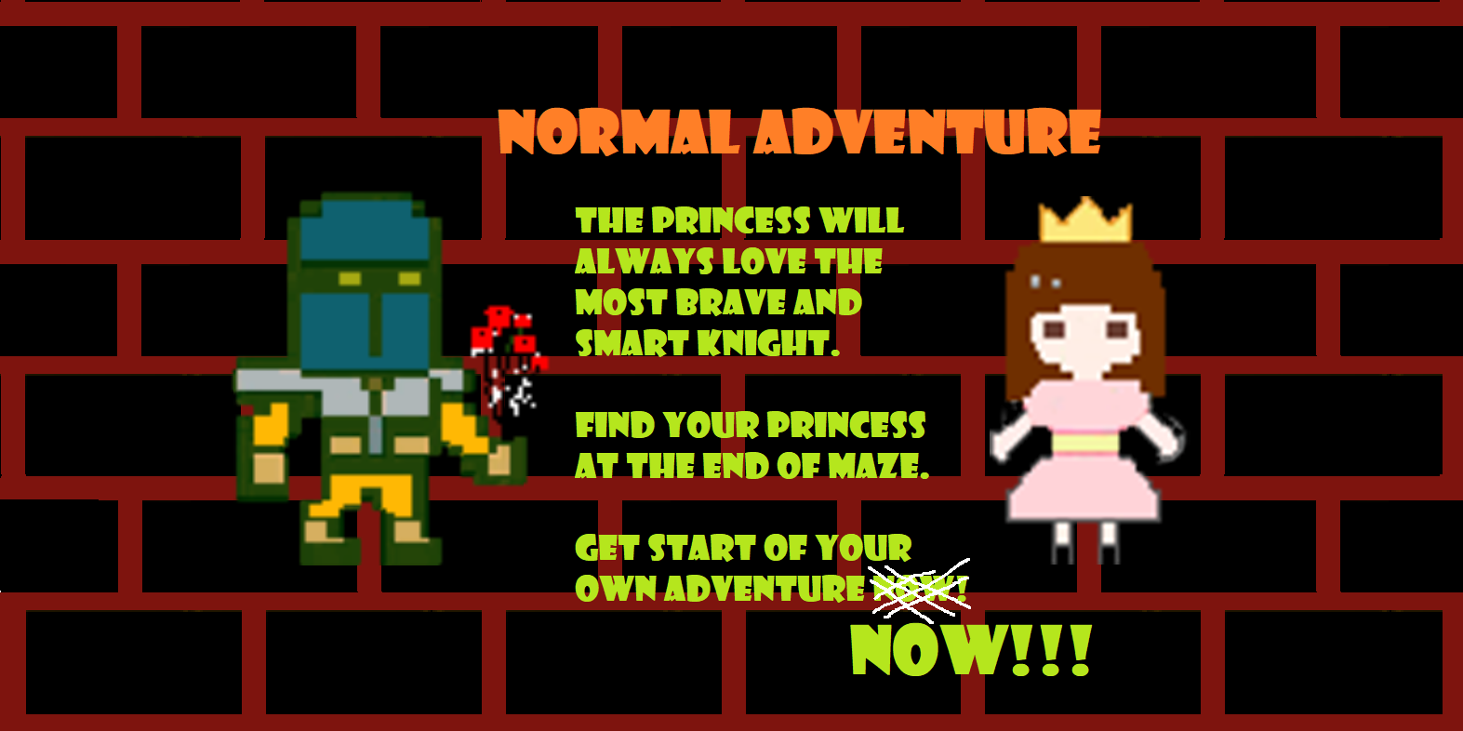

Design Document for:

Normal Adventure

One Liner, i.e. The Ultimate Racing Game

“Something funny here!”™

All work Copyright ©1999 by Normal adventure

Written by Normal adventure team

Version # 1.00

Name of Game 1
Design History 5
Version 1.10 5
Version 2.00 5
Version 2.10 5
Game Overview 6
Philosophy 6
Philosophical point #1 6
Philosophical point #2 6
Philosophical point #3 6
Common Questions 6
What is the game? 6
Why create this game? 6
Where does the game take place? 6
What do I control? 6
How many characters do I control? 6
What is the main focus? 6
What’s different? 7
Feature Set 8
General Features 8
Multi-player Features 8
Editor 8
Game play 8
The Game World 9
Overview 9
World Feature #1 9
World Feature #2 9
The Physical World 9
Overview 9
Key Locations 9
Travel 9
Scale 9
Objects 9
Weather 9
Day and Night 9
Time 10
Rendering System 10
Overview 10
2D/3D Rendering 10
Camera 10
Overview 10
Camera Detail #1 10
Camera Detail #2 10
Game Engine 10
Overview 10
Game Engine Detail #1 10
Water 10
Collision Detection 10
Lighting Models 11
Overview 11
Lighting Model Detail #1 11
Lighting Model Detail #2 11
The World Layout 12
Overview 12
World Layout Detail #1 12
World Layout Detail #2 12
Game Characters 13
Overview 13
Creating a Character 13
Enemies and Monsters 13
User Interface 14
Overview 14
User Interface Detail #1 14
User Interface Detail #2 14
Weapons 15
Overview 15
Weapons Details #1 15
Weapons Details #2 15
Musical Scores and Sound Effects 16
Overview 16
Red Book Audio 16
3D Sound 16
Sound Design 16
Single Player Game 17
Overview 17
Single Player Game Detail #1 17
Single Player Game Detail #2 17
Story 17
Hours of Game-play 17
Victory Conditions 17
Multi-player Game 18
Overview 18
Max Players 18
Servers 18
Customization 18
Internet 18
Gaming Sites 18
Persistence 18
Saving and Loading 18
Character Rendering 19
Overview 19
Character Rendering Detail #1 19
Character Rendering Detail #2 19
World Editing 20
Overview 20
World Editing Detail #1 20
World Editing Detail #2 20
Extra Miscellaneous Stuff 21
Overview 21
Junk I am working on… 21
“XYZ Appendix” 22
“Objects Appendix” 22
“User Interface Appendix” 22
“Networking Appendix” 22
“Character Rendering and Animation Appendix” 22
“Story Appendix” 22

Design History

This design document outlines our team’s game for entry 2020’s GameFleadh. This document will include the basic ideas about our game and some approaches that we used in our game.

Our team designed several versions of our game, in order to let players experience the joy of our game, we developed several versions for this game, in each version, we deleted some features that are not very suitable for our game, and also add some new features in every version which will allow player feel more fun and improve our game playability. Our team also fixed some bugs in each version.

Version 1.00

- Initial design decisions and discussed with our team members and wrote those ideas into design documents
- Decide which game engine is suitable for our game, we finally choose unity as our game engine.

Version 1.10

Version 1.10 is the first version of the design where a major revision has been made now that much more is known about the game. After many hours of design, many decisions have been made. Most of these large design decisions are now reflected in this document.

Included in the changes are:

- Add an extra level to the game, now the game include four levels.
- Add some new features to each level of our game in order to interact with players, such as collect the key in order to enter to the next level.

Version 2.00

Included in the changes are:

- Added background music to our game.
- Added a new role in our game.
- Added some monsters in the final level of the game.

Game Overview

Philosophy

Philosophical point #1

Our primary game design goal was to create some mazes for players, players will play the role of knights, the knight will across lots of mazes and finally rescue the trapped princess. Our team hopes that players will use this game to increase the spirit of adventure in real life and dare to challenge the difficulties that the players may face in real world.

Philosophical point #2

Our game use Unity game engine as our engine, which means that the game can easily be deployed across a wide range of platforms if needed. As a result, we hope our game can have cross-platform capabilities, so players can play our games anytime, anywhere.

Common Questions

What is the game?

Our game is called normal adventure. This is a 2D maze game. The theme of this game is that the knight which is the player, he needs to travel through some different kinds of mazes, and finally rescue the princess.

Why create this game?
Most of the computer science students are a group of people who often play games. Many students learn computer science in order to design their own games in the future. This race gives us a good chance to make our little dream come true. Through this experience we also learned about the design process of the game. By trying out your own games, we were aware of a lot of problems with code and game logic.
By creating this game, our team hopes to use this game to increase our programming ability, learning a new program language which is C#, learning how to build a game by using the Unity game engine and also learn the process of making games. And as a student, our team members also want to increase our interests in computers and to make our team members more competitive in the future.

Where does the game take place?
This game takes place in a dungeon. A princess is trapped at the bottom of the dungeon. The king sends the bravest warrior to rescue the princess. This warrior needs to pass through the maze in each room in the dungeon and finally rescued the princess at the bottom.

What do I control?

The player will control the bravest knight that sent by the king to rescue the princess by passing through all the mazes. The player will only control one character which is the knight, by using arrow keys and space bar on the keyboard to find the right direction and collect items to get out of the maze of every room.

What is the main focus?

The main focus is on how to find the right way to get out of the maze. Those mazes contain some collection tasks and include a dodge mechanism.

What’s different?

The normal adventure is an unusual combination of mazes which contains different ways in order to pass each maze, the way to clear the maze in each room is different from the other rooms. Compared with the maze games of the same level on the market, our game contains two different modes of the maze which are horizontal mazes and vertical mazes.

Feature Set

General Features
Platformer + maze
2D graphics
32-bit color

Gameplay

A mix of platform games and maze adventures
Different experiences for every maze part.
Interesting music and art style.

The Game World

Overview

The game takes place on a normal dungeon. A normally dressed knight walks through the normal maze in a normal way to get out of the princess trapped deep in the ground.

World Feature #1
Platform part
In normal world when you walk to the next level you need to pay coins. So, in normal adventure, Knights can only open the door to the next pass if they gather the gold coins scattered on the ground at each level.

World Feature #2
Maze part
Open door requires a key, a heart-shaped lock can only be opened by a heart-shaped key. Use the right key to open the right door and continue your adventure.
Keys in the second maze have the ability to distort space. These keys will transfer you to a random location on the map until all the keys are collected, and the door is clearly displayed in sight.
Third maze contains some monsters “slim”. This kind of monster is ineffective against physical attack knight must avoid contact with monsters. When there is Slim blocking the way, try to find other ways out.

The Physical World

Overview
Knight can move left and right and press space button to jump. Knight will stop when moving to touch the bricks. When a knight jumps, his head hits the brick above, and the knight will stand on the floating ground.
When a knight collects gold coins, he thinks of a specific music when a knight touches the keys and doors and princesses, triggers a specific scene.

Key Locations

Travel
Press “A” or left arrow to move left and “D” or right arrow to move right.
Press space to jump in platform part.

Scale
Platform part: 49*49
Maze: 20*20 in average.

Objects

Knight: game role.
Princess: NPC. Touch to win the game.
Monster Slim: NPC if touch the slim, game role will return to the origin position of the maze.
Key: It's going to have different effects when game role touch it.
Door: load to next level
Coin: After touching, accumulate the value of the coin and then collect the full coin, trigger the condition for the door to open.
Brick: Used to form background walls and floors.

Rendering System

Overview

The game will be rendered using the Unity 2D engine’s toolset for sprite rendering. Unity’s editor and interface allows us to control layer management and tile map.

2D/3D Rendering

The game will be rendered using the Unity 2D engine.

Camera

Overview

The camera moves as the character moves. The ratio shown is 4:3

Game Engine

Overview
Unity engine has many convenient functions which can make us quickly generate maps, items and other materials. It is easily for us to set collider and trigger by using Unity engine. We can simply drag the folder into specific position to run UI, audio materials. And the software comes with a physics engine, and we just need to set parameters to do some of the basic operations.

Collision Detection
We add box collider2D for bricks, doors, Slims and keys. The size is the whole game object body.
Then add rigidbody 2D for the knight in order to make knight to move.
Then we add raycast to detect the position of the object. The knight has 3 raycasts, two at the bottom to detect whether the knight is on the ground. One on the bottom to detect whether the knight is touching the bricks on the top.

The World Layout

Overview

The platform part is a square of 49*49 size. And contains many bricks which are randomly generated on the map to make the whole map more complicated. And some coins are dragged on the map randomly and knight can collect them.
The maze part is 20*20 for each maze on average. The layout is the normal maze layout as other maze games and we add more elements to make the game have more fun such as enemy, key and so on.

Game Characters

Overview
Platform part: Create two characters: knight and princess
Maze part: create enemy Slim.

Creating a Character

For the knight we use a still picture of a character as a prefab of the character. And then make two animations: idle and walk which are represents 2 actions. For the princess we dragged the princess directly into the game.

Enemies and Monsters

For enemy, we use code to generate randomly on the map.

User Interface

Overview

The game uses a simple interface for beginning of the game. From the main menu the quit options button provides access to out of the game and the play button access to start the game.
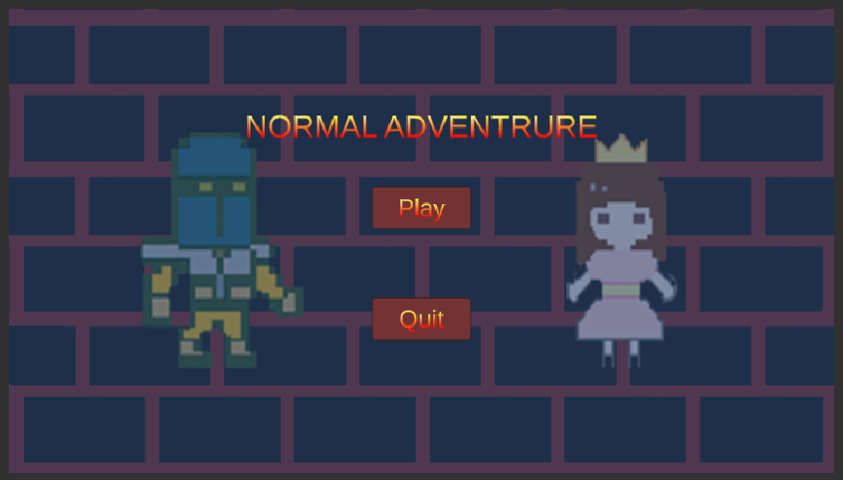
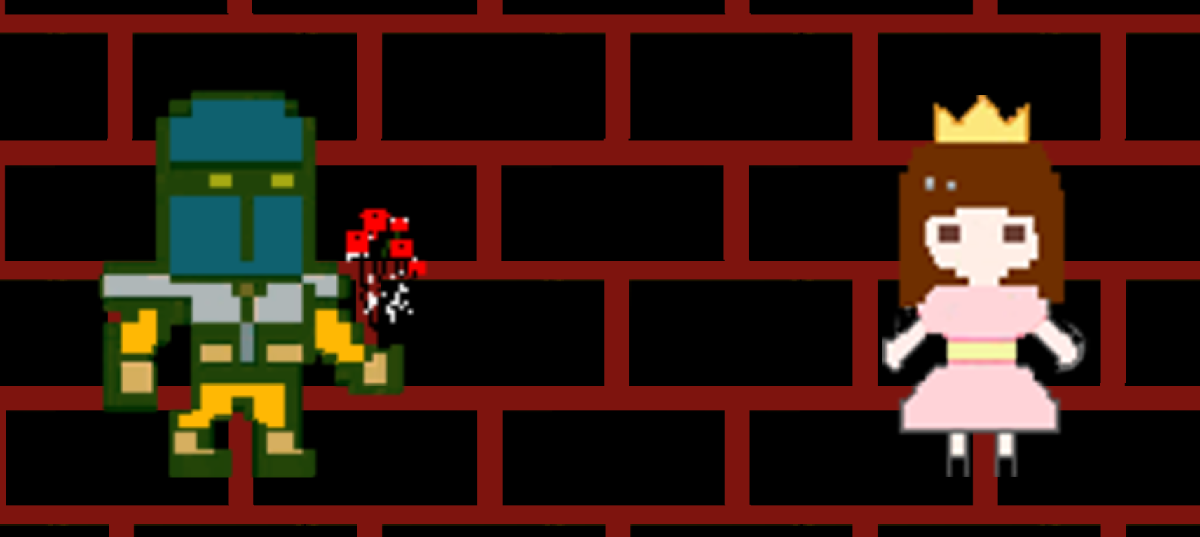

Coins

When the knight collects the coins, there is a sound of coins being picked up.
Doors
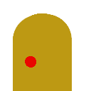

The door in platform part is used to teleport knight to the maze level.
The door in maze part is used to teleport knight to the platform part.
Key

The key in the first maze level is used to unlock the door. Different keys unlock different doors.
The key in the second maze level is used to teleport knight to random position, only if knight collect all the keys, the door will allow the knight to go.

Knight
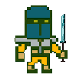
The game role.
Princess
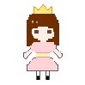
A knight wins only when he meets a princess.
Bricks
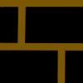
Yellow bricks are the background of the platform part.

Red bricks are the wall of the maze part.
Ground

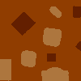
Ground element for the 3 maze parts.
Ladder
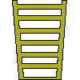
Ladder is used to connect maze and platform.

Weapons

Overview

No weapon system. We love peace.

Musical Scores and Sound Effects

Overview

Our game is a dungeon plus maze adventure game. So, we want to create light music as our background music, but we are not expert to make music so finally our music sounds very funny. We thought the style of the game goes with our music will give users a strong expression. And we also made a sound effect for the coin collection.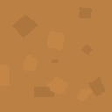

Sound Design

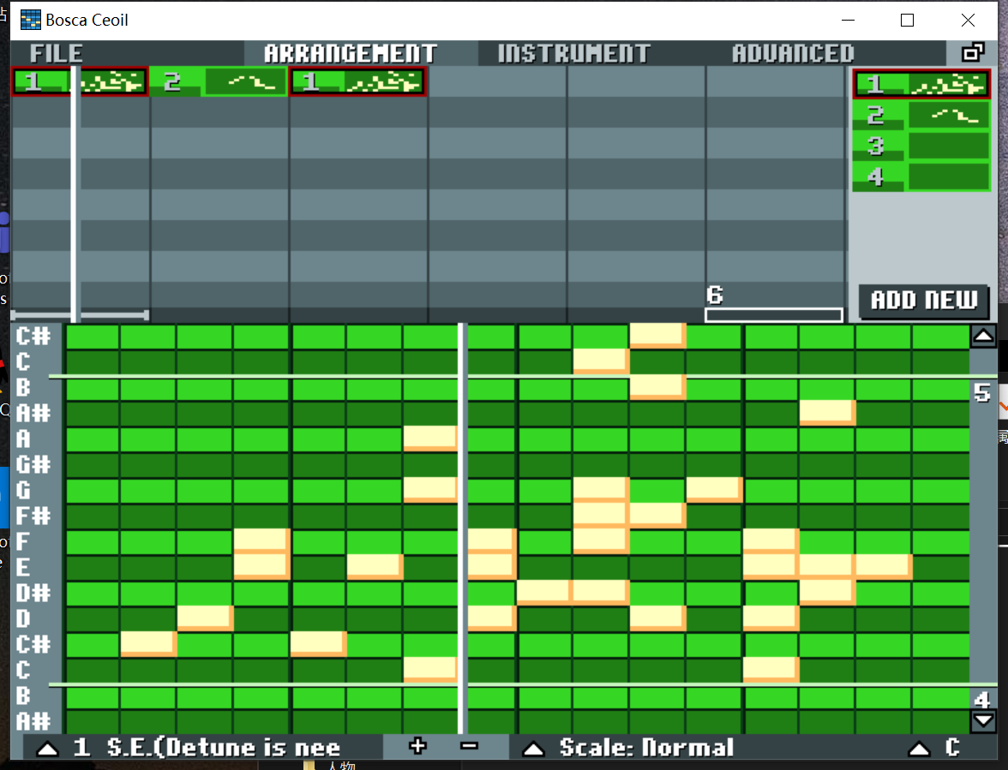
We use Ceoil to make our music. ceoil which is the music create program that contains many musical instruments eg: piano guitar wind and so on. inside of this program you need to choose a instrument and then left click on the box then it will give you a feedback as an analog voice which you choose from the instrument. Also you can create many pieces then connect whatever you want as a full music.

Single-Player Game

Overview

The difficulty of the game is medium in total. Some game level design are complicated which may annoy users when they are playing the game with our background music.

Single Player Game Detail #1

Single Player Game Detail #2

Story

The princess was trapped in the dungeon, and the knight went through a lot of difficulties to save her beloved princess.

Hours of Gameplay

About Half an hour

Victory Conditions

Find the princess.

Character Rendering

Overview

There are two status of the knight. He has rigid body to control moving and box collider to limit his moving.

Character Rendering Detail #1
The two status of the knight are idle and walking. For each status we create four images to make the animations.

Character Rendering Detail #2
The knight can not only change to walking animation, but also change its rotation.

World Editing

Overview

The world is consist of wall and floor prefabs.

World Editing Detail #1
The wall prefabs have component called box collider, so that the knight would not go through the walls.

World Editing Detail #2
For some levels, the map is formed by coding. For the other levels, the map is created by tile map function.

Extra Miscellaneous Stuff

Overview

The idea of maze design is come from our previous game experience. In the maze, we put lots of triggers with different functions, to make it more fun.

Junk I am working on…

In one of the levels, there are some keys teleport the knight to a random space.

If the knight touch the slim, he will go back to the start point but kill the slim.

“Character Rendering and Animation Appendix”
About the character we choose knight and princess. All the characters and picture made by photo shop and sai. For the animation part of the character we create 4 or 5 picture of the character and then connect together inside of the unity looks like an animation

“Story Appendix”

For the story it is like the knight want to find the true love which is the princess who is at the end of the maze. The knight will face to many problem and finally get the end of the maze. Example the knight need to get all the golden coins then the door will appear which connect with the next maze. Example 2 the knight have to get correct color key for the door which have to match the same color.
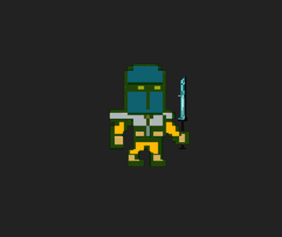

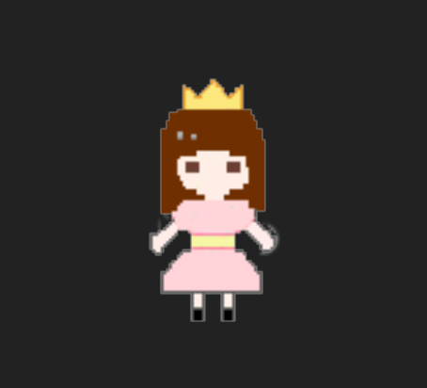

That is our game. We took two weeks to complete this game. At first, we have no experience of how to make a game. However, as we watch some wonderful teaching videos and learn Unity from Internet, we really gained a lot. We know there are still lots of parts can be improved better. Looking forward to your idea and improvement plan of our game.

Thanks

Team Normal Adventure

